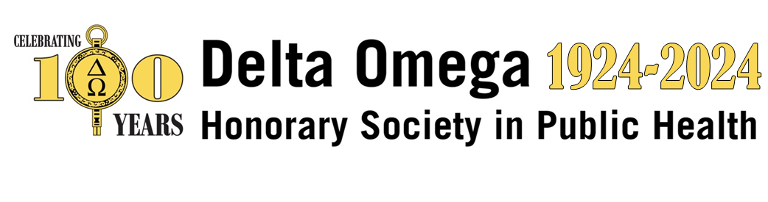

2024 Innovative curriculum award

Call for Nominations Deadline: September 4, 2024

The Delta Omega National Public Health Honor Society is pleased to announce a call for nominations for the 2024 Delta Omega Award for Innovative Public Health Curriculum. The National Office may also recognize a runner-up winner. The society created this annual award as part of its efforts to promote excellence in public health education, research, and practice.

The award objectives are to highlight public health course curricula that are innovative and:
- Integrate actual public health practice experiences and examples into classroom discussions and exercises
- Highlight models of collaborative, comprehensive, and community-based public health practice and scholarship
- Emphasize the application of public health principles and science-based decision-making
- Focus on skills development
- Involve community-sector partners in teaching
- Use case studies and other examples of projects suitable for a multi-disciplinary audience

The winner of the Innovative Curriculum award will be invited to present at the Delta Omega annual meeting and the Academic Public Health Caucus poster session at the APHA 2024 Annual Meeting.

The runner-up (to be chosen at the discretion of the Executive Committee), will be featured on the Delta Omega website, receive a certificate for the award, and is invited to list this honor on his/her CV. Winners and nominees may also be invited to present during a webinar series in early 2025.
Eligibility
Nominations are limited to CEPH-accredited schools and programs of public health with an active chapter of Delta Omega. Nominations should be self-submitted by individual faculty members. Submissions from previous years are eligible as long as the curriculum is actively being taught.

Applications should include:
- A brief (no more than 3 pages) overview of the course, describing its rationale, and the public health educational needs that it addresses
- Examples of course materials, including course purpose, syllabus, learning objectives, reading materials, exercises/assignments, examinations, and evaluations (no more than twenty pages)

Applications will be scored using the following model:

- Integrates actual public health practice experiences and examples into classroom discussions and exercises and highlights models of collaborative, cooperative, and community-based public health practice and scholarship – 20%
- Focuses on skills development and emphasizes the application of public health principles and the use of science-based decision-making – 25%
- Involves community sector partners in teaching - 10%
- Makes use of case studies and examples of projects suitable for a multi-disciplinary audience - 20%
- Demonstrates innovation - 25%

*Submitted materials should not exceed 20 pages. Submission link: 2024 DO Innovative Curriculum Award Form

Any questions or suggestions, contact us at info@deltaomega.org.

